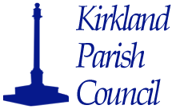
Clerk Gillian Benson
57, Hamers Wood Drive,
Catterall,
Garstang,
PR3 1YN
Telephone 01995 600689
Web Site www.kirklandparish@org.uk
E-mail clerk@parishes.org.uk
8th September 2020

The next Meeting of Kirkland Parish Council will be held on 15th September, 2020,
at 7.30pm, as a virtual meeting.

Members of the public and press are invited to attend this virtual meeting.
Please contact the clerk by 15.00 on Monday 12th September, to express your interest in attending this virtual meeting.

Yours Sincerely,
G. Benson
Clerk to the Parish Council

AGENDA

Apologies

Vacancies in the office of Parish Councillor

Notification of Interests

Minutes of the last meeting

Public Participation

State of The Avenue

Christmas Tree

Planning consultation by the Government

Code of Conduct

Village Defibrillator

Planning Applications

Finance

Verbal Reports for information

Questions Raised by Members for information

The next meeting will be 13th October, 2020 at 7.30pm.

